**Database Management System Case Studies**

**Parking Lot Management System**

**Aim:** The capstone project entitled **Parking Lot Management System** is an information system that can manage the records and transactions on parking lots and facilities. The platform also includes a booking and reservation module wherein the customers can select a parking slot and book or reserve the parking slot based on their preferred date and time.

**Description**: A typical parking lot consists of one or more blocks that are further subdivided into floors. Each floor contains multiple wings that help drivers orient themselves and remember their parking spots. These are usually labeled with letters, such as “A”, “B”, “C”, and so on. A floor usually has a height limit that restricts certain vehicles from entering the parking lot. Additionally, a floor contains several uniquely numbered parking slots. Some of these slots are reserved for handicapped people; others can be reserved by regular visitors at a certain cost.

The three main sections are as follows:-

* Parking lot
* Customer
* Parking reservation

**Entities:**

In the Parking Lot Management System we have the following entities:-

1. **Parking_lot - The central part of the organization for which this software has been designed. It has attributes like ‘Name’ to distinguish it from any other parking lots and ‘Address’ to define its location.**
2. **Floor - The parking lot will have many parking floors.**
3. **Block - Each parking floor will have many parking spots. Our system will support different parking spots 1) Handicapped, 2) Compact, 3) Large, 4) Motorcycle, and 5) Electric.**
4. **Parking_slot - Each parking floor will have a display board to show available parking spots for each spot type. This class will be responsible for displaying the latest availability of free parking spots to the customers.**
5. **Customer - All customers can get a parking ticket and pay for it**
6. **Regular_pass -** **This class will encapsulate a parking ticket. Customers will take a ticket when they enter the parking lot.**
7. **Parking_slip - This class will encapsulate all the operations that an attendant can perform, like scanning tickets and processing payments.**
8. **Parking_slot_reservation – Conformation of slot booked at a particular spot in the parking lot.**

## E‐R Diagram

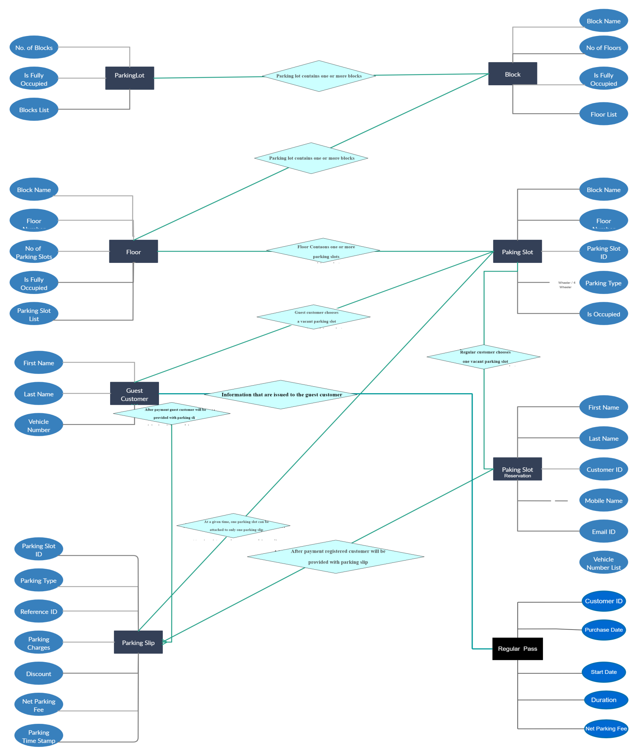

## Tables

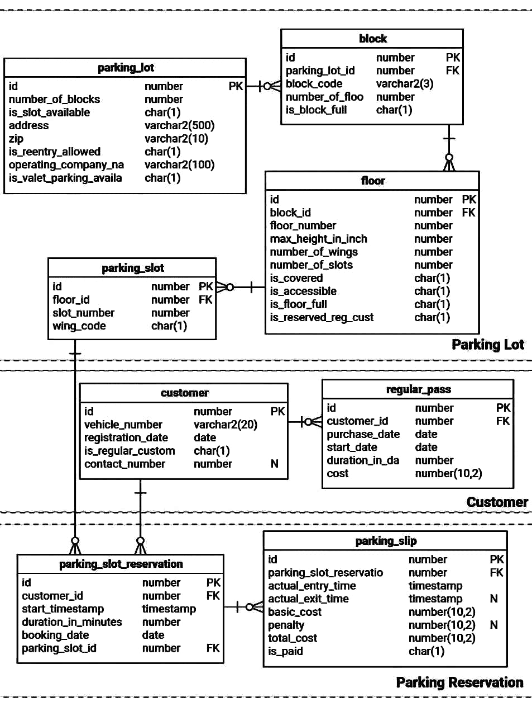

**Tables**

Create table parking lot (id number, number_of_blocks number, slot_available char(1), address varchar2(500), zip varchar2(10), reentry_allowed char(1), operating_company_na varchar2(100), is_valet_parking_available char(1));

create table block(id number, parking_lot_id number, block_code varchar2(3), number_of_floo number, is_block_full char(1));

Create table regular_pass(id number,customer_id number,purchase_date date,start_date date,duration_in_da number,cost number(10,2);

Create table customer(id number,vehical_number varchar2(20),registration_date date, is_regular_custom char(1),contact_number number);

Create table parking_slot(id number,floor_id number,slot_number number,wing_code char(1));

Create table parking_slot_reservation(id number,customer_id number,start_timestamp timestamp,duration_in_minutes number,booking_date date,parking_slot_id number)

Create table parking_slip (id number,parking_slot_reservation number,actual_entry_time timestamp,actual_exit_time timestamp,basic_cost number(10,2),penalty number(10,2),total_cost number(10,2),is_paid char(1));